Cloud Architect

Business Applications

**Lab Steps**

Task 1: Sign in to AWS Management Console

1. Click on the  button, and you will get redirected to AWS Console in a new browser tab.
2. On the AWS sign-in page,

* Leave the Account ID as default. Never edit/remove the 12 digit Account ID present in the AWS Console. otherwise, you cannot proceed with the lab.
* Now copy your **User Name** and **Password** in the Lab Console to the **IAM Username and Password** in AWS Console and click on the **Sign in** button

     3. Once Signed In to the AWS Management Console, Make the default AWS Region as **US East (N. Virginia) us-east-1.**

Task 2: Create an Email Identity using SES

1. Make sure you are in the **US East (N. Virginia) us-east-1** Region.
2. Navigate to  menu at the top. Click on **Amazon Simple Email Service**in the  section.
3. On the left side menu, **Select**
4. Click on 
5. Enter following details:
   * Identity type: Select **Email Address**
   * Email address: **Enter your valid Email ID**.
   * **Leave other options as default.**
   * Click on 

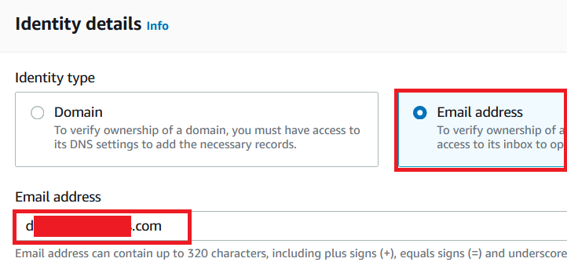

1. You will get the below **IAM error**, just ignore that. You will not need this permission to complete the lab.

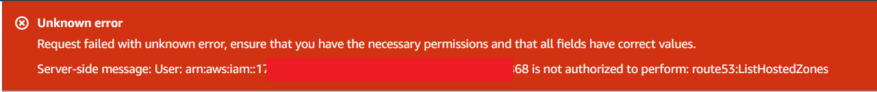

1. Now you will be able to see that the **Identity Status** on the Email will be **Unverified.**

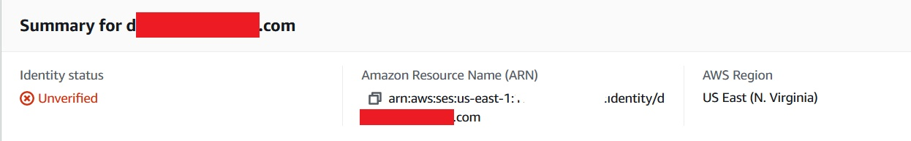

Task 3: Verify the Email address

1. AWS will send a confirmation email to the email that you provided in the above step.
2. Log in to your mailbox and you will be able to see a mail from Amazon Web Services.

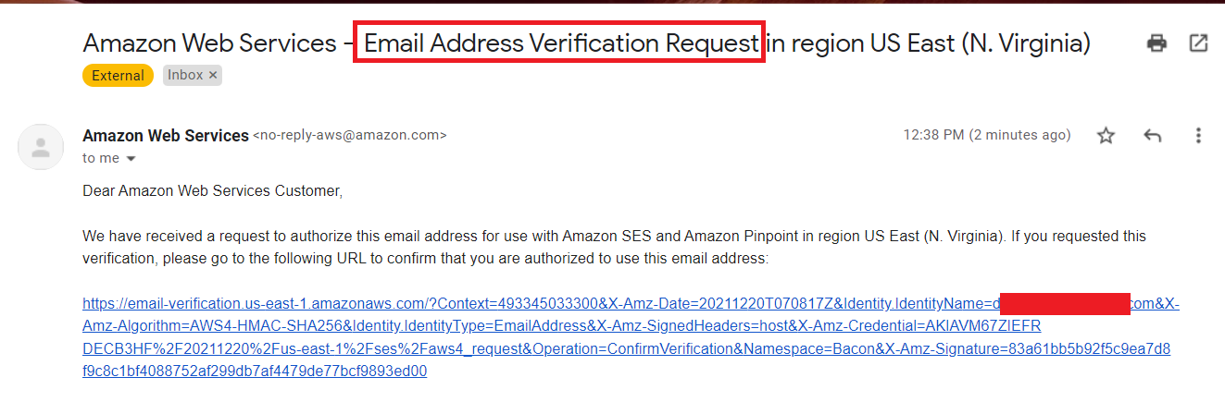

1. Once you click on the **link**, you will be routed to the success page.

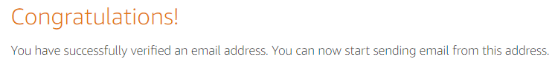

1. Now go to the **SES Email Address page** and **refresh the page**. You will be able to see the Verification status as **Active**.

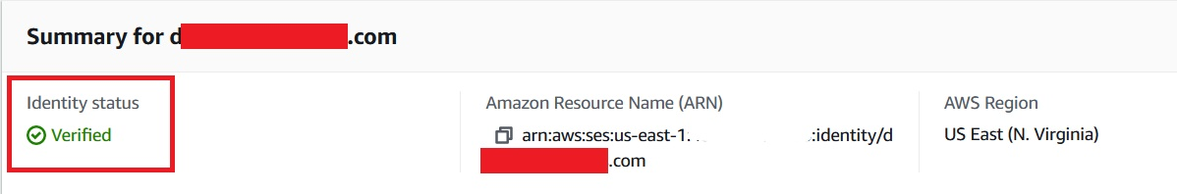

Task 4: Send a Test Email

1. Let us send a test email to the same email address.
2. Click on **Send Test Email**.

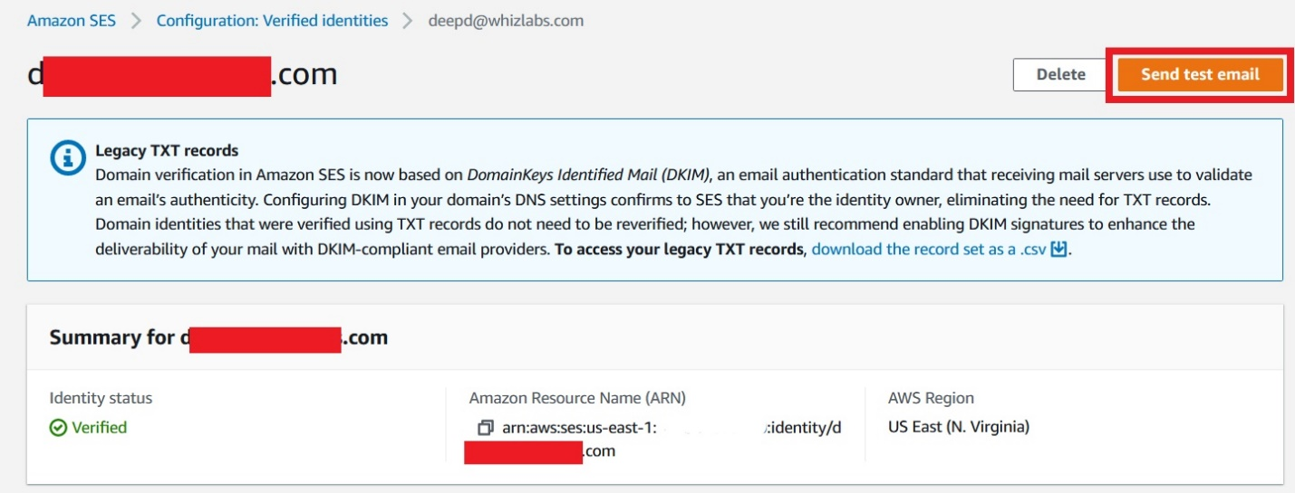

1. Make the following changes:
   * Email Format: Select **Formatted** (keep it as default)
   * From: Your email address will be present by **default**
   * Scenario: Select **Custom** from the drop-down menu
   * Custom recipient: **Give the same email address** (for testing purposes)
   * Subject: Enter **Sending a Test Email**
   * Body: **Type any text as you wish**
   * **Leave other options as default.**
   * Click on **Send Test Email**.

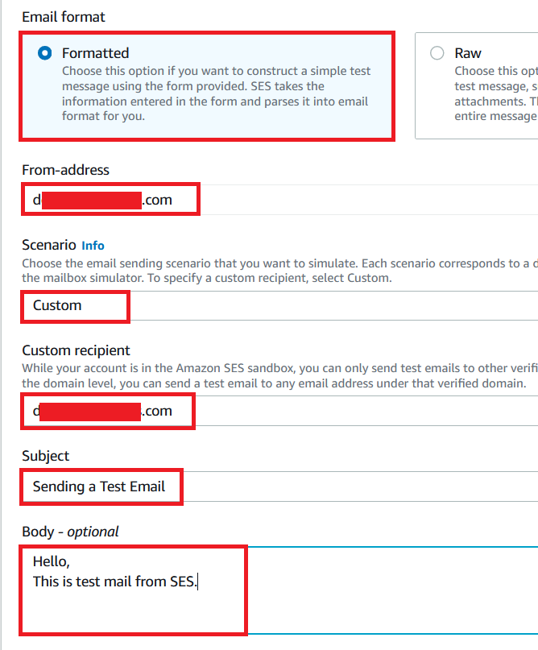

1. Verify the mail received to your Inbox. If it is not present in your inbox, check in the **spam**.

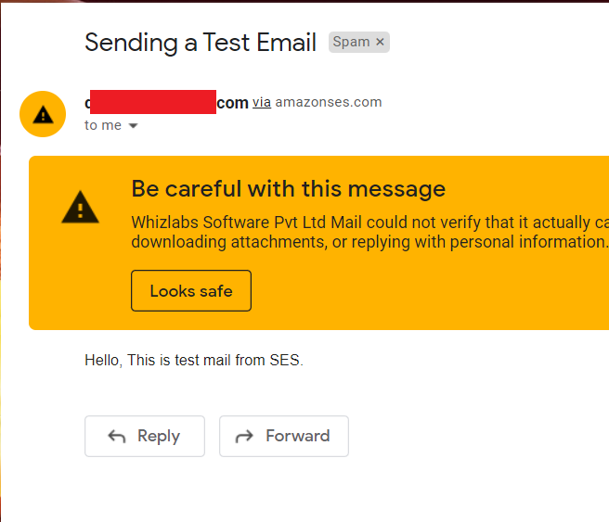

Task 5: Validation Test

1. Once the lab steps are completed, please click on the  button on the left side panel.
2. This will validate the resources in the AWS account and displays whether you have completed this lab successfully or not.
3. Sample output :

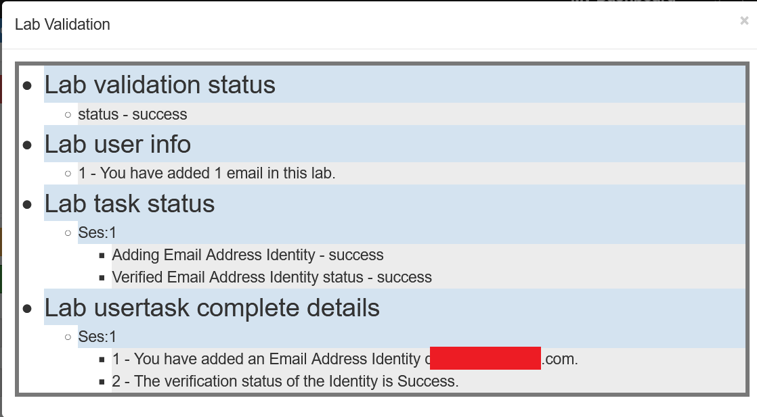

**Completion and Conclusion**

1. You have successfully logged in to the AWS Management console.
2. You have successfully created an SES Email address.
3. You have successfully created verified the Email address.

**End Lab**

1. Sign out of the AWS Account.
2. You have successfully completed the lab.